Web Technology

Assignment – 1

Title: NB Navigator

Name: Omkar Kabde

Roll No: 1601-22-749-058

Section: CSE – IOT

**Aim:** Building a personalized travel guide website with HTML, CSS, and Bootstrap. It allows users to enter the city or pin code to unveil nearby tourist hotspots. The website contains beautiful visuals and immersive animations.

**Description:**

My project in the Web Technologies lab is about creating a dependable tourist guide using HTML, CSS, and Bootstrap. The main goal is to make a website where people can enter their location details and avail top nearby tourist locations

I started by making the basic structure of the website using HTML. Then, I added styles and designs using CSS to make it look attractive. With Bootstrap, I made sure the website looks good on different devices like phones and laptops.

The website has a fun animation of the Taj Mahal in the login and main pages. The title of my project, NB Navigator stands for Neighborhood Navigator

is a pun on the old and gold internet browser Netscape Navigator.

I've made it easy for users to sign up and log in so they can access my webpage

Throughout the project, I've focused on making the website look good and adding fun animations using CSS and Bootstrap. From floating images to smooth transitions, I've tried to make the website engaging and enjoyable to use.

**Future Plans:**

Moving forward, I want to make my website work as intended, by actually showing top locations, which I plan on doing by integrating through the Google Maps APIs.I also plan to incorporate JavaScript to add dynamic functionality and interactive elements to the website.

. I want to give users the ability to create accounts, share their personal likes and dislikes, and connect with other members of the travel community. It's all about building a vibrant platform for discovering popular and hidden gems

!

# Main Page:

**main.html:**

<!DOCTYPE *html*>

<html *lang*="en">

<head>

    <meta *charset*="UTF-8">

    <title>NBNavigator</title>

    <link *rel*="stylesheet" *href*="main.css">

</head>

<body>

<header>

    <video *src*="animation.mp4" *alt*="Icon" *autoplay* *loop*></video>

    <h1>Discover your city!</h1>

    <p>Enter your city or pincode to discover popular tourist locations around you!</p>

    <form>

        Enter City - <input *type*='text'><br><br>

        Enter pincode - <input *type*='text'>

    </form>

</header>

<div *class*="menu-container">

    <nav *style*="display:flex; justify-content:center;">

        <ul *class*="category">About Us

            <li *class*="item"><a *href*="#overview">Overview</a></li>

            <li *class*="item"><a *href*="#team">Our Team</a></li>

            <li *class*="item"><a *href*="#contact">Contact Us</a></li>

        </ul>

        <ul *class*="category">Services

            <li *class*="item"><a *href*="#webdesign">Web Design</a></li>

            <li *class*="item"><a *href*="#development">Development</a></li>

            <li *class*="item"><a *href*="#marketing">Marketing</a></li>

        </ul>

        <ul *class*="category">Popular Cities

            <li *class*="item"><a *href*="#Hyderabad">Hyderabad</a></li>

            <li *class*="item"><a *href*="#Mumbai">Mumbai</a></li>

            <li *class*="item"><a *href*="#Kolkata">Kolkata</a></li>

        </ul>

    </nav>

</div>

</body>

</html>

# Styles.css:

* {

    margin: 0;

    padding: 0;

    box-sizing: border-box;}

body {

    font-family: Arial, sans-serif;

    color: #FFF;

    text-align: center;}

header {

    border-radius: 10px;

    background-color: #985d5d;

    box-shadow: 0 2px 4px **rgba**(0, 0, 0, 0.1);

    padding-bottom:20px}

video {

    width: 275px;

    height: 275px;

    margin-bottom: 10px;

    margin-top: 10px;}

header h1 {

    font-size: 36px;

    margin-bottom: 10px;}

header p {

    margin-bottom: 20px;}

.menu-container {

    display: flex;

    justify-content: space-evenly;

    align-items: center;

    width : 100%;}

nav {

    background-color: #3c3535;

    text-align: center;

    width : 100%;

    padding-top:20px;}

nav ul {

    list-style: none;}

nav ul li {

    padding: 5px;

    margin-right:5px;

    margin-left:5px;

}

nav ul li a {

    text-decoration: none;

    color: #0096FF;

    transition: background-color 0.3s ease;}

nav ul li a:hover {

    background-color: #ccc;}

# Login Page:

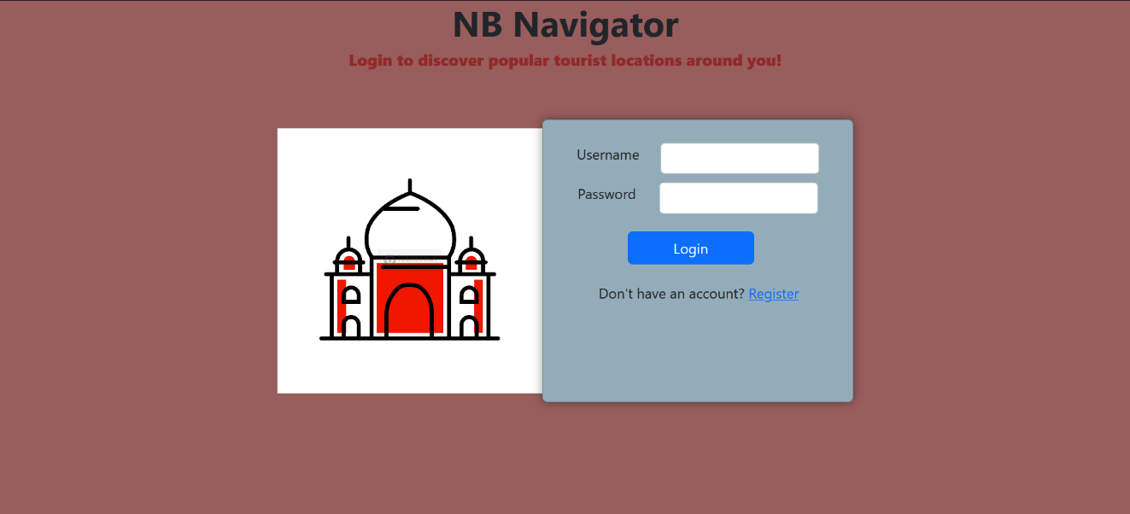

**Login.html:**

<!doctype *html*>

<html *lang*="en">

<head>

  <meta *charset*="utf-8">

  <meta *name*="viewport" *content*="width=device-width, initial-scale=1">

  <title>Bootstrap</title>

  <link*href*="https://cdn.jsdelivr.net/npm/bootstrap@5.3.2/dist/css/bootstrap.min.css" *rel*="stylesheet" *integrity*="sha384-T3c6CoIi6uLrA9TneNEoa7RxnatzjcDSCmG1MXxSR1GAsXEV/Dwwykc2MPK8M2HN" *crossorigin*="anonymous">

  <style>

    .flex-container {

      display: flex;

      justify-content: center;

      margin-top: 25px;}

    .card {

        width: 100%;

        background-color: #91d6eba4;

        box-shadow: 0 0 10px **rgba**(0, 0, 0, 0.4);}

    .btn {

        display: flex;

        justify-content: center;

        align-items: center;

        margin-left: 25%;

        width: 45%;

        margin-top: 20px;

        margin-bottom: 5px;}

    h1 {

        display: flex;

        justify-content: center;

        font-weight: bold;

        margin-top: 100 px;}

    .form-group {

        display: flex;

        justify-content: space-around;

        margin: 10px;}

    p {

        margin-top: 20px;

        margin-left: 47px;}

    input {

        display: flex;

        width: 60%;

        justify-content: right;

        border-radius: 5px;

        border: 1px solid #ccc;

        height: 35px;}

    label {

        display: flex;

        text-align: left;

        justify-content: left;}

    video {

    width: 300px;

    height: 300px;

    margin-bottom: 10px;

    margin-top: 10px;}

  </style>

</head>

<body *style*="background-color: #985d5d;">

    <h1>NB Navigator</h1>

    <h1 *style*="color: #922a2a; font-size: 18px;"><strong>Login to discover popular tourist locations around you!</strong></h1>

    <br>

  <div *class*="flex-container">

    <video *src*="animation.mp4" *alt*="Icon" *autoplay* *loop*></video>

    <div *class*="card" *style*="width: 22rem;">

      <img *src*="" *class*="card-img-top" *alt*="">

      <div *class*="card-body">

        <div *class*="form-group">

            <label *for*="username">Username</label>

            <input *type*="text" *id*="username" *name*="username">

        </div>

        <div *class*="form-group">

            <label *for*="password">Password</label>

            <input *type*="password" *id*="password" *name*="password">

        </div>

        <a *href*="lab2.html" *class*="btn btn-primary">Login</a>

        <p>Don't have an account? <a *href*="register.html">Register</a></p>

      </div>

    </div>

  </div>

</body>

</html>

# Registration Page:

**Register.html:**

<!DOCTYPE *html*>

<html *lang*="en">

<head>

    <meta *charset*="UTF-8">

    <meta *name*="viewport" *content*="width=device-width, initial-scale=1.0">

    <title>Login/Register</title>

    <style>

        body {

            font-family: Arial, sans-serif;

            background-color: #985d5d;

            margin: 0;

            padding: 0;

            display: flex;

            justify-content: center;

            align-items: center;

            height: 100vh;

        }

        .container {

            background-color: #fff;

            padding: 20px;

            border-radius: 5px;

            box-shadow: 0 0 10px **rgba**(0, 0, 0, 0.1);

        }

        .container h2 {

            margin-top: 0;

        }

        .form-group {

            margin-bottom: 10px;

        }

        .form-group input {

            width: 100%;

            padding: 8px;

            border: 1px solid #ccc;

            border-radius: 3px;

            font-size: 16px;

        }

        .form-group button {

            width: 100%;

            padding: 8px;

            background-color: #333;

            color: #fff;

            border: none;

            border-radius: 3px;

            font-size: 16px;

            cursor: pointer;

        }

        .form-group button:hover {

            background-color: #555;

        }

    </style>

</head>

<body>

<div *class*="container">

<h2>Register</h2>

    <form *action*="success.html">

        <div *class*="form-group">

            <input *type*="text"  *placeholder*="Full Name" *required*>

        </div>

        <div *class*="form-group">

            <input *type*="email" *placeholder*="Email" *required*>

        </div>

        <div *class*="form-group">

            <input *type*="password" *placeholder*="Password" *required*>

        </div>

        <div *class*="form-group">

            <button *type*="submit">Register</button>

        </div>

    </form>

</div>

</body>

</html>

# Success Page:

<!DOCTYPE *html*>

<html *lang*="en">

<head>

    <meta *charset*="UTF-8">

    <meta *name*="viewport" *content*="width=device-width, initial-scale=1.0">

    <title>Registration Successful</title>

    <style>

        body {

            font-family: Arial, sans-serif;

            background-color: #985d5d;

            margin: 0;

            padding: 0;

            display: flex;

            justify-content: center;

            align-items: center;

            height: 100vh;

        }

        .container {

            background-color: #fff;

            padding: 20px;

            border-radius: 5px;

            box-shadow: 0 0 10px **rgba**(0, 0, 0, 0.1);

            text-align: center;

        }

        .container h2 {

            margin-top: 0;

        }

        .container p {

            margin-bottom: 20px;

        }

        .container a {

            text-decoration: none;

            color: #333;

            font-weight: bold;

        }

        .container a:hover {

            color: #555;

        }

    </style>

</head>

<body>

<div *class*="container">

    <h2>Registration Successful</h2>

    <p>Thank you for registering!</p>

    <p>You can now <a *href*="login.html">login</a> to your account.</p>

</div>

</body>

</html>

# Conclusion:

In wrapping up, developing this travel blog website has been an exhilarating journey of learning. Through hands-on experience with HTML, CSS, and Bootstrap, I've acquired invaluable skills in web development and design. From constructing the foundational framework to incorporating animations and interactive components, every stage has been rewarding.

As I gaze towards the horizon, I'm filled with excitement for the future enhancements awaiting the website. Implementing Google OAuth for authentication and harnessing JavaScript for dynamic functionalities present thrilling opportunities for advancement. Moreover, I aspire to evolve the website into a reliable platform that fosters camaraderie among fellow travelers,